ISLAMIC UNIVERSITY OF TECHNOLOGY
DHAKA, BANGLADESH
ORGANIZATION OF ISLAMIC COOPERATION
DATABASE MANAGEMENT SYSTEMS LAB

Name: Antara Arifa Mullick
Student ID: 210042132
Department: Computer Science and Engineering
Program: B.Sc. in Software Engineering

Report preparing for Lab Task

Here is the problem statement -
Execute the banking.sql script using command. It creates a set of tables along with values that maintain the following schema:
ACTOR
ACT_ID NUMBER
ACT_FIRSTNAME VARCHAR2
ACT_LASTNAME VARCHAR2
ACT_GENDER

CASTS
ACT_ID NUMBER
MOV_ID NUMBER
ROLE VARCHAR2

REVIEWER
REV_ID NUMBER
REV_NAME VARCHAR2

DIRECTOR
DIR_ID NUMBER
DIR_FIRSTNAME VARCHAR2
DIR_LASTNAME VARCHAR2

MOVIE
MOV_ID NUMBER
MOV_TITLE VARCHAR2
MOV_YEAR NUMBER
MOV_LANGUAGE VARCHAR2
MOV_RELEASEDATE DATE
MOV_COUNTRY VARCHAR2

RATING
MOV_ID NUMBER
REV_ID NUMBER
REV_STARS NUMBER

DIRECTION
DIR_ID NUMBER
MOV_ID NUMBER
Here, the boldfaces denote the primary keys and the arcs denote the foreign key relationships.
In this lab, you have to write all SQL statements in an editor first and save them with .sql extension.
Then execute the SQL script.
Write SQL statements for the following queries:
1.Find the name of the actors/actresses that are also directors (with and without set operator).
Solution Approach
SELECT DISTINCT ACT_FIRSTNAME, ACT_LASTNAME
FROM ACTOR
WHERE (ACT_FIRSTNAME || ' ' || ACT_LASTNAME) IN (
SELECT DIR_FIRSTNAME || ' ' || DIR_LASTNAME
FROM DIRECTOR
);

SELECT NAME
FROM (
SELECT ACT_FIRSTNAME || ' ' || ACT_LASTNAME AS NAME
FROM ACTOR
UNION ALL
SELECT DIR_FIRSTNAME || ' ' || DIR_LASTNAME AS NAME
FROM DIRECTOR
)
GROUP BY NAME
HAVING COUNT(*) > 1;

SQL Command

2.Find the actresses with the same first name.
Solution Approach
SELECT ACT_FIRSTNAME, COUNT(*) AS NUM_ACTRESSES
FROM ACTOR
WHERE ACT_GENDER = 'F'
GROUP BY ACT_FIRSTNAME
HAVING COUNT(*) > 1;
SQL Command
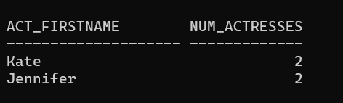
3.Find the list of all the full names stored in the database.
Solution Approach
SELECT ACT_FIRSTNAME || ' ' || ACT_LASTNAME AS FULL_NAME
FROM ACTOR
UNION
SELECT DIR_FIRSTNAME || ' ' || DIR_LASTNAME AS FULL_NAME
FROM DIRECTOR;
SQL Command
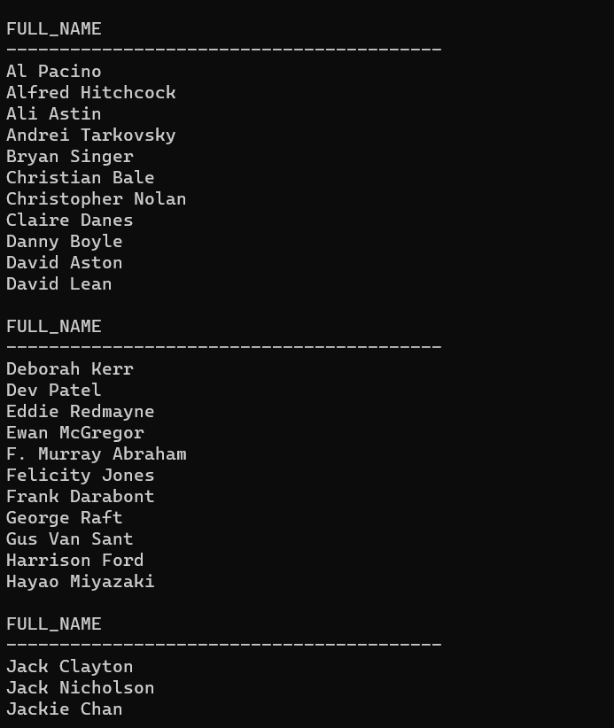
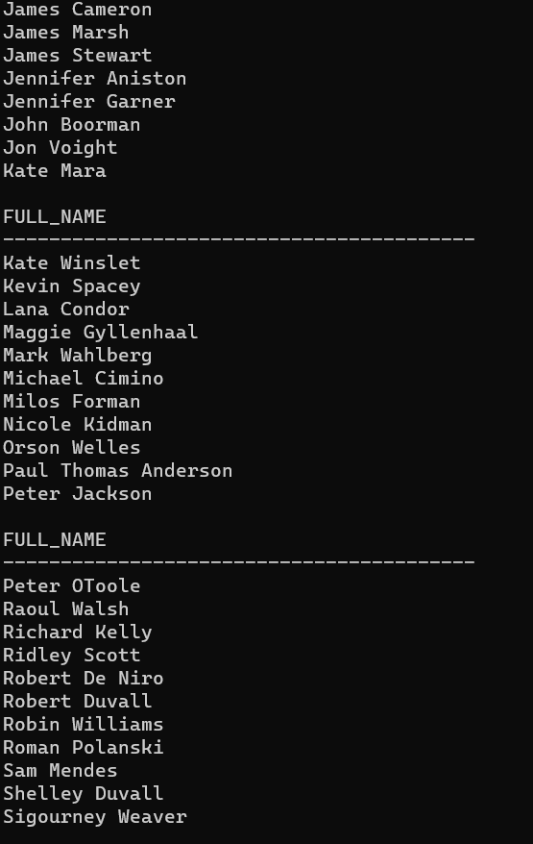
4.Find the movie titles that did not receive any ratings.
Solution Approach
SELECT MOV_TITLE
FROM MOVIE
WHERE MOV_ID NOT IN (
SELECT DISTINCT MOV_ID
FROM RATING
);
SQL Command

5.Find the average rating of all movies.
Solution Approach
SELECT AVG(REV_STARS)
FROM RATING;
SQL Command

6.Find the minimum rating for each movie and display them in descending order of rating.
Solution Approach
SELECT MOV_ID, MIN(REV_STARS) AS MIN_RATING
FROM RATING
GROUP BY MOV_ID
ORDER BY MIN_RATING DESC;

SQL Command
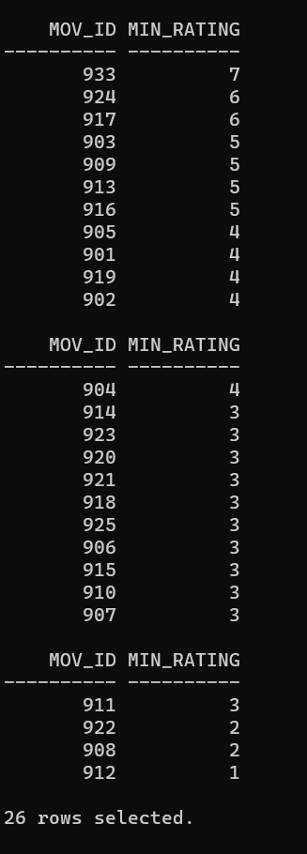
7.Find the title of the movie having an average rev_star higher than the average rev_star of all
the movies.
Solution Approach
SELECT MOV_TITLE
FROM MOVIE
WHERE MOV_ID IN (
SELECT MOV_ID
FROM RATING
GROUP BY MOV_ID
HAVING AVG(REV_STARS) > (SELECT AVG(REV_STARS) FROM RATING));

SQL Command
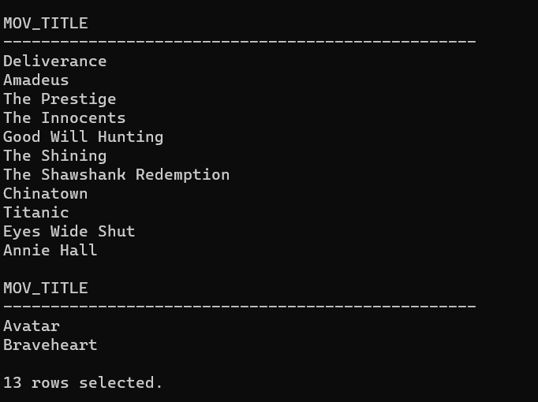
8.Find the name of actors/actresses and the number of ratings received by the movies in which
they played a role.
Solution Approach
SELECT a.ACT_FIRSTNAME || ' ' || a.ACT_LASTNAME AS ACTOR_ACTRESS_NAME,
m.MOV_TITLE,
COUNT(r.MOV_ID) AS NUMBER_OF_RATINGS
FROM ACTOR a, CASTS c, MOVIE m, RATING r
WHERE a.ACT_ID = c.ACT_ID
AND c.MOV_ID = m.MOV_ID
AND m.MOV_ID = r.MOV_ID
GROUP BY a.ACT_FIRSTNAME, a.ACT_LASTNAME, m.MOV_TITLE
ORDER BY ACTOR_ACTRESS_NAME, NUMBER_OF_RATINGS DESC;

SQL Command



9.Find the name of the director of the movie having the highest average rev_star.
Solution Approach
SELECT d.DIR_FIRSTNAME || ' ' || d.DIR_LASTNAME AS Director_Name
FROM DIRECTOR d
JOIN DIRECTION di ON d.DIR_ID = di.DIR_ID
JOIN (
SELECT MOV_ID, AVG(REV_STARS) AS Avg_Rev_Star
FROM RATING
GROUP BY MOV_ID
HAVING AVG(REV_STARS) = (
SELECT MAX(Avg_Rev_Star)
FROM (
SELECT MOV_ID, AVG(REV_STARS) AS Avg_Rev_Star
FROM RATING
GROUP BY MOV_ID)))
r ON di.MOV_ID = r.MOV_ID;

SQL Command

10.Find all the movie-related information of movies acted and directed by the same person.
Solution Approach
SELECT m.MOV_ID, m.MOV_TITLE, m.MOV_YEAR, m.MOV_TIME, m.MOV_LANGUAGE, m.MOV_RELEASEDATE, m.MOV_COUNTRY
FROM MOVIE m, CASTS c, DIRECTION d
WHERE m.MOV_ID = c.MOV_ID
AND m.MOV_ID = d.MOV_ID
AND c.ACT_ID = d.DIR_ID;

SQL Command

11.Find the title and average rating of the movies that have an average rev_star of more than 7.
Solution Approach
SELECT m.MOV_TITLE, AVG(r.REV_STARS) AS AVERAGE_RATING
FROM MOVIE m, RATING r
WHERE m.MOV_ID = r.MOV_ID
GROUP BY m.MOV_TITLE
HAVING AVG(r.REV_STARS) > 7
ORDER BY AVERAGE_RATING DESC;

SQL Command
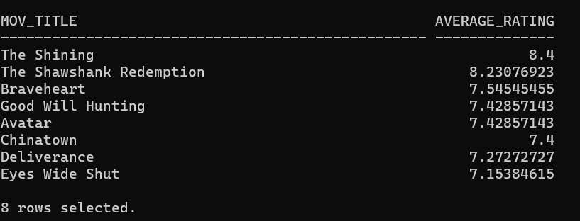
12. Find the reviewer who gives the highest number of lowest rev_star.
Solution Approach
SELECT r.REV_NAME, COUNT(*) AS Lowest_Rev_Star_Count
FROM REVIEWER r, RATING ra
WHERE r.REV_ID = ra.REV_ID
AND ra.REV_STARS = (
SELECT MIN(REV_STARS)
FROM RATING)
GROUP BY r.REV_NAME
HAVING COUNT(*) = (
SELECT MAX(Count_Rev_Star)
FROM (
SELECT COUNT(*) AS Count_Rev_Star
FROM REVIEWER r, RATING ra
WHERE r.REV_ID = ra.REV_ID
AND ra.REV_STARS = (
SELECT MIN(REV_STARS)
FROM RATING)
GROUP BY r.REV_NAME));
SQL Command
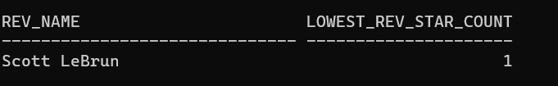
13. Find the name and average runtime of movies of different actors/actresses. Do not include
any actor/actress who worked with ‘James Cameron’.
Solution Approach
SELECT (a.ACT_FIRSTNAME || ' ' || a.ACT_LASTNAME) AS Actor_Actress_Name, AVG(m.MOV_TIME) AS Average_Runtime
FROM ACTOR a, CASTS c, MOVIE m
WHERE a.ACT_ID = c.ACT_ID
AND c.MOV_ID = m.MOV_ID
AND a.ACT_ID NOT IN (
SELECT DISTINCT c.ACT_ID
FROM CASTS c, DIRECTION d, DIRECTOR di
WHERE c.MOV_ID = d.MOV_ID
AND d.DIR_ID = di.DIR_ID
AND (di.DIR_FIRSTNAME || ' ' || di.DIR_LASTNAME) = 'James Cameron')
GROUP BY a.ACT_FIRSTNAME, a.ACT_LASTNAME;
SQL Command
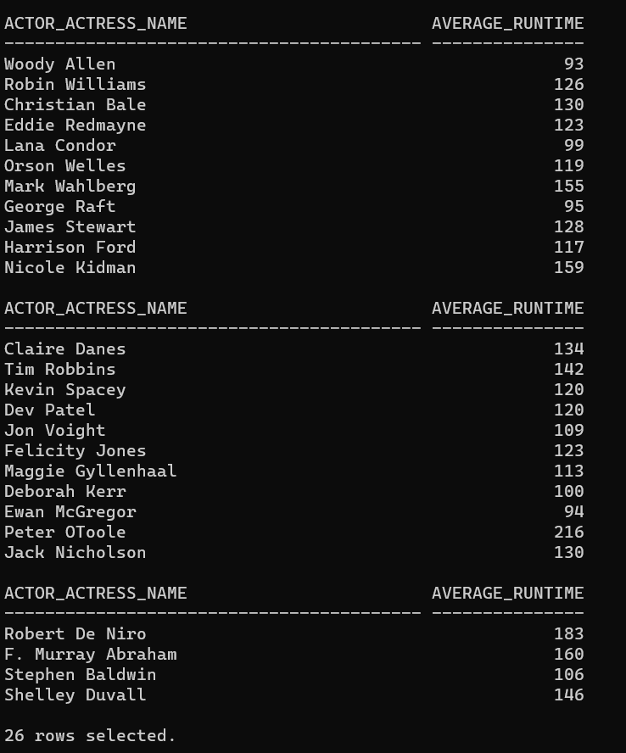
Problems faced :
Syntax Errors: SQL queries must have some strict syntax requirements. Incorrectly worded queries might result in syntax problems and as a beginner I did struggle to get the syntax properly.
Understanding Database Structure: As I was not so familiar with the structure of the database I am working with, it might be difficult to determine which tables exist, what columns they include, and how they relate to one another.
Table Creation: Creating tables with the right structure and data types were a bit tricky. Defining primary keys,Foreign keys, and constraints correctly is essential.
Connect Table : to connect multiple table command is a bit difficult to me.

